OPERATIONAL EFFICIENCY ANALYSIS FOR MANUFACTURING INDUSTRY
BACKGROUND AND PROJECT OVERVİEW
This project aims to analyze the efficiency of manufacturing operations in four critical segments; production, quality, maintenance and supply chain on a synthetic dataset generated by artificial intelligence, inspired by real industry data (Siemens, GE etc.). The project delivers a dashboard synthesizes 11 North Star metrics with 19 segment-specific visualizations built on a data-driven methodology and data quality validation.
Business Questions
Category | Primary Question | Key Metrics
Production Performance | How much capacity is being utilized? | OEE, Production efficiency, Throughput, Actual-Target Varience
Quality | What is the performance of quality system? | First Pass Yield, QC Pass Rate, Defect Rate,
Downtime & Maintenance | Why do breakdowns occur? | Maintenance need, Downtime Frequency, Avg. Downtime
Supply & Inventory | How is supply chain efficiency? | Inventory Turnover, Avg. Lead Time, Warehouse Utilization, Product Trend
Sensor & Anomaly | Are failures predictable? | Error Code Distribution, Sensor Temprature Dev. Index
Cost | What is driving the cost? | Total Cost, Avg. Unit Cost, COPQ, Defect Cost

Insights and recommenditions are following on the key area:
Output and efficiency trends: Production performance overview by shift, machine and operator
Quality performance analytics: Qc status and defect rate/cost analysis
Technical reliability and sensor diagnostics: Downtime and error code - sensor corelation analysis
Logistics and warehouse analytics: Product, warehouse utilization and logistics trends
The interactive Tableau dashboard are available here. (link eklenecek)
DATASET OVERVİEW

Data Characteristics
Metric | Value
Total Records | 10,500 transactions
Attributes | 25 dimensions
Time Period | 01.01.2025 – 05.02.2026
Missing Data Pattern | 3 columns, 1 is critical with 50% missing
Data Quality | 82.5% overall cleanliness
Data Limitations: Due to random generation, some unrealistic patterns exist (e.g. machine performance exceeding 100%).
The prompt and Python code used to generate the data are available here. (link to be added).
Data quality enhancements and a summary can be accessed here. (link to be added).
Descriptive statistics can be accessed here. (link to be added).
SQL queries for data manipulation is provided here. (link to be added).
EXECUTIVE SUMMARY
Manufacturing operations demonstrate stable but suboptimal performance across most
metrics with one critical quality crisis requiring immediate intervention.

The production line demonstrated consistent performance throughout the year, generating 1.71 million units of output with a controlled cost structure of $99 million. Maintaining a unit cost of $55 confirms operational efficiency while the annual COPQ of $2.1 million indicates continued potential for improvement in quality processes. This clearly reveals areas requiring strategic intervention alongside strong operational discipline.
Operational performance was a period where the numbers show clearly: OEE (Overall Equipment Effectiveness) remaining at 68% and production efficiency at 70% indicated areas for improvement of 17 and 15 points respectively compared to targets. First-Pass Yield was at standard level with 98%. However, the inventory turnover rate remaining at 0.7 highlighted the need for optimization in inventory management. This presented a performance story where operational discipline and areas for improvement were balanced and clearly visible.
Critical performance indicators presented a clear picture of operational risks: a 39% Quality Pass rate, falling short of a 40% Fail rate, indicated a critical quality issue. 51% maintenance requirement and 34% downtime frequency highlighted the need for high-priority intervention. However, the consistent average lead time of 15 days across all delivery methods suggested that process flow was still proceeding in a controlled manner at certain points. This picture summarized an operational reality requiring urgent action in the areas of quality and maintenance.
INSIGHTS DEEP DIVE
Output and Efficiency Trends
The fact that production efficiency remained constant at 70% throughout the period, 15 points below the industry benchmark of 85%, indicated a need for systematic performance improvement. While shift-based performance fluctuated within a narrow range of 69-71%, the evening shift had the lowest efficiency at 69%, highlighting the potential for improvement in operator and resource planning. The distribution of OEE between 64-72% per machine with 20% of machines performing below average, supported the conclusion that the problem stemmed from planning and capacity utilization. This situation demonstrates that a consistent but low level of efficiency prevailed throughout the operation and the root cause should be made in systemic planning processes.
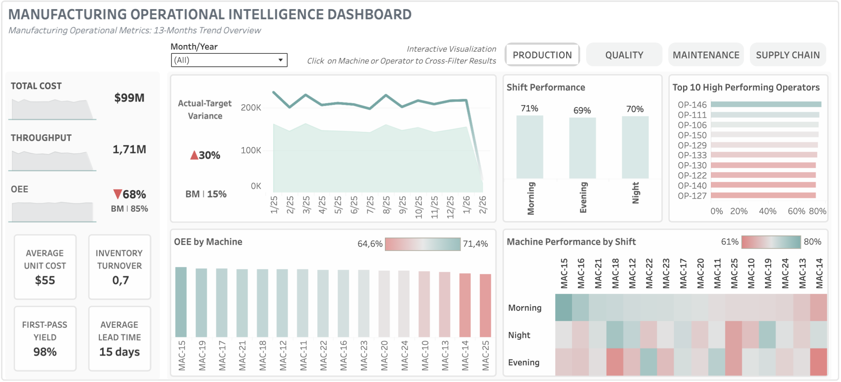
Quality Performance Analytics
The quality overview clearly revealed a structural breakdown in the process: a pass rate remaining at 39%, a fail rate exceeding the success rate at 40% and a pending rate of 20% indicated a serious systemic breakdown in the quality control flow. Defect rates of 2–3% per machine. Especially the fact that MAC-20, MAC-22, MAC-24, MAC-25 had a pass rate of only 42% showed that the problem was related to equipment calibration, maintenance or material flow not the operators. The rework rate remaining at a low level of 0.8% revealed that the capacity for recovering process errors was limited. The total annual quality cost reaching $2.1 million, equivalent to approximately 2.1% of revenue, strongly emphasized the need to address the financial impact of quality problems at a strategic level.
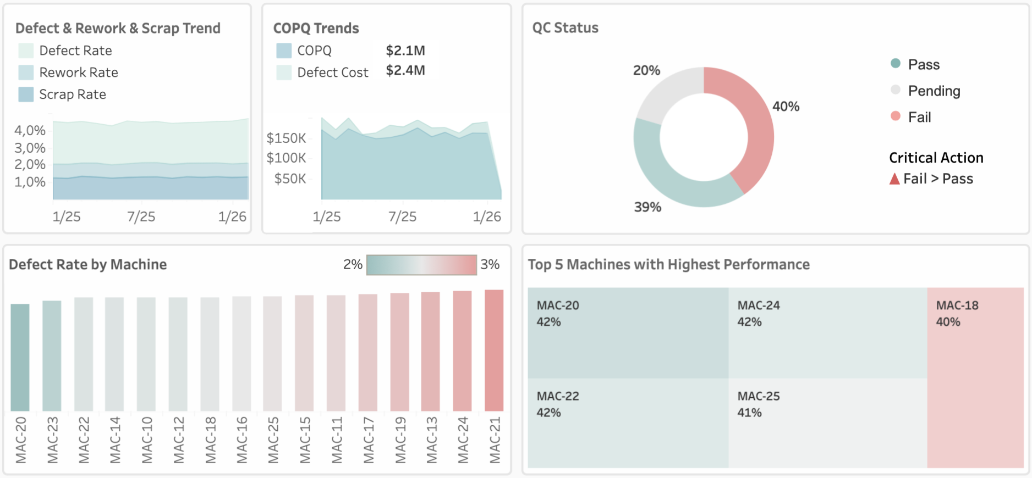
Technical Reliability and Sensor Diagnostics
Maintenance data clearly revealed a structural challenge in equipment health: 51% of machines required maintenance, and 34% of operations experienced downtime, coupled with an average of 5 minutes of consistent downtime, indicating a significant impact on operational continuity. Machine sensor temperature showed a positive picture with very low deviations while error code E01 was the most frequent problem at 40% and that machine sensors could not predict failures with near-zero correlation values ​​(vibration 0.01–0.04, temperature -0.01–-0.04) revealed that the current sensor monitoring infrastructure is unreliable. This situation shows that redefining calibration thresholds in maintenance processes and conducting comprehensive equipment audits for mechanical or electrical failure modes undetectable by sensors is necessary.
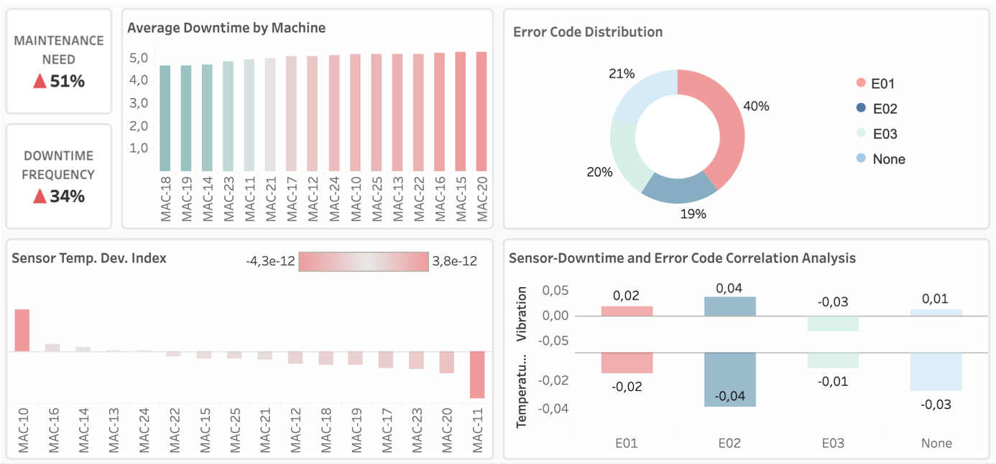

Logistics and Warehouse Analytics
Supply chain performance showed healthy portfolio diversification with product distribution evenly distributed among four products (25%) while the concentration of 70% of sales in Germany indicated a distinctly European-centric market. Warehouse utilization showed Zone A having the highest occupancy rate at 40%, with other zones only at 20%, presenting an opportunity for consolidation to reduce operational costs. Consistent lead time performance of 15–16 days across all transport methods confirmed process maturity while the inventory turnover rate of 0.66, well below the optimal range (4–10), revealed that stocks were held for longer than necessary and capital efficiency was decreasing. This situation highlighted the need for optimization in demand forecasting and production planning as a strategic priority.
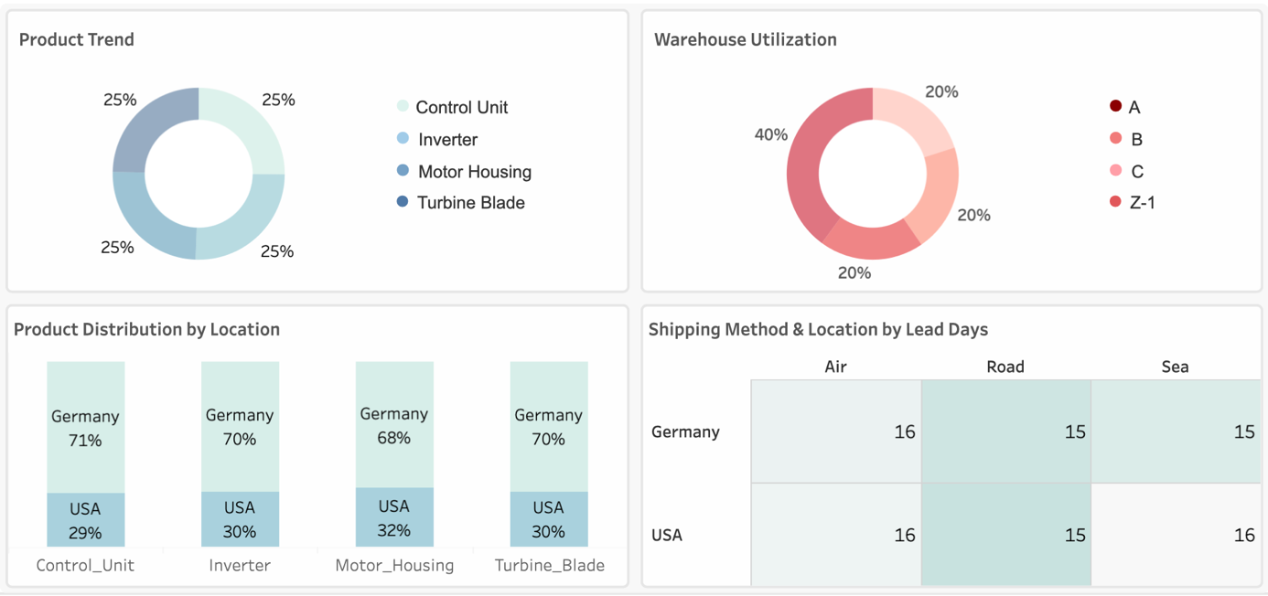

BUSINESS RECOMMENDATIONS
Priority | Operation | Recommendations
1 | Quality | Quality system failure with low Qc pass (39%) is a critical issue and needs immediate quality audit on machines MAC-21, MAC-24, MAC-13, MAC-19 to reduce defect rate from 2-3% to <1% and increase pass rate from 39% to 85%.  Plan operator training focusing on quality standards and problematic machine operation to support quality improvements. (Targeting 85%+ success rate)
2 | Maintenance | Optimizing maintenance scheduling (51% Need), implement a preventive maintenance program and discontinue sensor-based prediction. This approach aims to reduce downtime frequency from 34% to below 20%, decrease machine-related interruptions, increase production capacity and minimize emergency repairs.  Given the near-zero correlation between current sensors and downtime, improving the ability to properly collect and update data (next-generation IoT investment) and advanced analytical applications such as machine learning should be explored in equipment failure prediction. The goal is to implement predictive maintenance and reduce downtime.
3 | Production | Reduce the production efficiency gap (15%) with capacity and demand analysis and production planning optimization. The aim is to increase efficiency from 70% to 85% (minimum target).  Conduct a comprehensive analysis of personnel, equipment allocation and operational procedures to ensure a minimum performance standard of 71% for the duration of the shift. Introduce supplementary control measures specifically for the evening shift.
4 | Supply Chain | Optimize inventory turnover rate with increasing the turnover rate from 0.7 to 4 (minimum) by improving demand forecasting and adjusting safety stock levels.  Consolidate underutilized warehouse zones and optimize material handling to reduce warehouse operational costs.  Product distribution 70/30 between Germany and the United States demonstrates a reliance on one region, thereby elevating risk exposure. Refine your regional strategy in alignment with emerging growth prospects.
5 | Executive | Foster a culture of continuous improvement and sustainable performance growth through monthly performance reviews and goal-setting practices to align with stakeholders.

